**Mr SGs Solutions Notes**

**Water as a solvent: chemical structure**

-A large number of the reactions we study in chemistry, including virtually all biologically important reactions occur in solution

-In the vast majority of these cases, water is the solvent in these solutions

-The chemical structure of water is what gives it the particular properties that make it the “universal solvent”

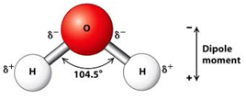

-Water is a bent asymmetrical molecule containing intramolecular covalent bonds

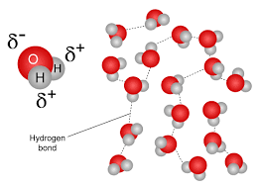

-Each of the OH bonds is highly polar, giving water the ability to form intermolecular hydrogen bonding forces

**Properties of water**

-Water has several unusual properties for such a small covalent molecule

-These properties result from the hydrogen bonding forces between adjacent water molecules and include:

-High MP and BP: It takes a significant amount of energy to overcome the hydrogen bonding forces during changes of state

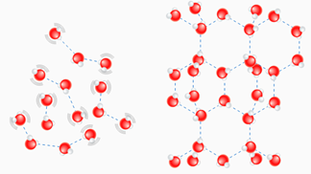

-Expands upon freezing: due to the crystal structure that results from the arrangement of dipoles in the solid

-High surface tension: due to strength of hydrogen bonding forces between water molecules at the surface and the molecules adjacent to (but not above) them

-High latent heat of vaporisation and fusion: It takes a large quantity of energy to change state completely at water boiling/freezing point, due to the strength of hydrogen bonding forces within water

-High heat capacity: Water has a significant ability to absorb and store heat energy, due to the ability of hydrogen bonding forces to absorb/store energy

**Formation of aqueous solutions**

-Solutions where water is the solvent are known as aqueous solutions

-Solutions are homogenous mixtures (the solvent and solute are uniformly distributed and indistinguishable from one another)

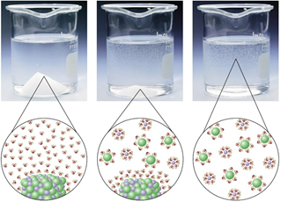

-When a substance dissolves, solute particles separate from one another, solvent particles separate from one another, and the solute and solvent particles become attracted to each other

-For a substance to dissolve, the forces between solute and solvent particles must be stronger than the forces between particles within the solvent and within the solute

-Substances are more likely to dissolve if their particles can better interact with the solvent molecules (this explains the 'like dissolves like' phenomenon)

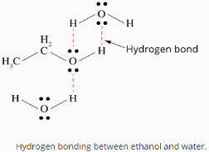

**Types of solute-solvent forces in aqueous solutions**

-Hydrogen bonding forces between water molecules and solutes that are covalent molecular compounds with a lone pair of electrons on a N/O/F atom (a H-N/O/F bond is not strictly required as water can supply the positive dipole needed for a hydrogen bonding force)

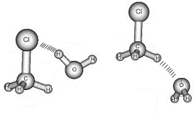

-Dipole-dipole forces between water molecules and polar covalent molecular compounds without H-N/O/F bonds, or lone pairs of electrons on N/O/F atoms

-Ion-dipole forces between water molecules and covalent molecular solutes that ionise when they dissolve, due to water removing a hydrogen atom from the solute molecule (e.g. hydrogen chloride will ionise when it dissolves, forming hydronium (H3O+) and chloride ions (Cl-))

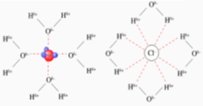

-Ion-dipole forces between water molecules and ionic substances that dissociate when they dissolve



**Note: Ionising is when a substance forms ions when it dissolves. Dissociating is when the ions that already existed in the lattice separate from each other**

**Electrolyte Strength**

**Solutions of ionic compounds**

-When ionic substances dissolve, they dissociate into their component ions

-Dissociation refers to the separation of an ionic lattice (it does not involve the creation of any new ions)

-As an example, a solution of sodium carbonate will be comprised of water molecules, sodium ions and carbonate ions

-The presence of these ions means that ionic solutions will conduct electricity (mobile charge carriers are required for a current to flow)

-Ionic solutions are strong electrolytes (they completely break up into ions when they dissolve)

**Solutions of covalent compounds**

-When most covalent molecular substances, their molecules remain intact

-As an example, a solution of glucose (C6H12O6) will only consist of water molecules and glucose molecules

-This solution would be an example of a non-electrolyte, as none of the solute particles will split up to produce ions

**Ionisation**

-Some covalent molecular substances will undergo ionisation when they dissolve

-Ionisation is when a neutral substance reacts to form ions

-When hydrogen chloride gas dissolves in water, it completely ionises to form hydrogen ions and chloride ions

-A solution of hydrogen chloride will consist of water molecules, hydrogen ions and chloride ions, with no hydrogen chloride molecules

-This solution would be an example of a strong electrolyte, as all of the solute particles will react to produce ions

-Other covalent molecular substances will only ionise to a small extent when they dissolve

-When ethanoic acid (CH3COOH) dissolves in water, only a small proportion of ethanoic acid molecules will ionise to form hydrogen ions and ethanoate (CH3COO-)

-A solution of ethanoic acid will contain water molecules, ethanoic acid molecules, hydrogen ions and ethanoate ions

-Such as solution is considered a weak electrolyte as only a small proportion of solute molecules react to form ions

-A solution of a weak electrolyte will be a poor conductor of electricity as there are less charged particles present than in a solution of a strong electrolyte

-For covalent molecular substances, strong acids (HCl, HNO3 & H2SO4) are strong electrolytes, weak acids and bases are weak electrolytes and all other covalent molecular substances are non-electrolytes

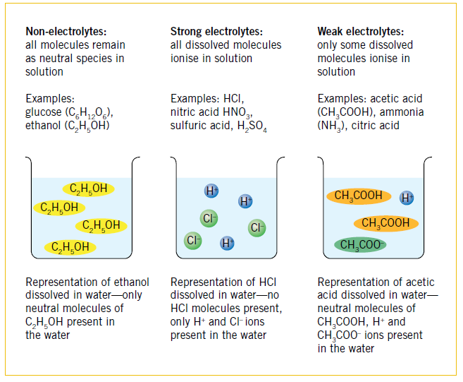

**Solubility**

**Classification of solutions**

-Solutions can be classified based on the amount of solute dissolved in them

-Unsaturated solutions are solutions that can dissolve more solute. If additional solute is added it will dissolve

-Saturated solutions are solutions that cannot dissolve more solute as they already contain the maximum amount the solvent can dissolve at that temperature. If additional solute is added it will not dissolve.

-Supersaturated solutions are solutions that contain more solute than is theoretically possible for the solvent to dissolve at that temperature (they are prepared by dissolving solute in the solvent at a higher temperature, where the solubility is greater and allowing it to slowly cool). If additional solute is added it will cause large amounts of solute to crystallise out of solution.

**Solubility**

-Solubility describes the amount of solute that can be dissolved in a certain amount of solvent

-The solubility of a substance depends on the strength of the solute-solvent forces compared to the forced within the solvent and within the solute (hence the “like dissolves like” guideline)

-Solubility also varies with temperature. We call the graph showing this variation the “solubility curve” for a substance

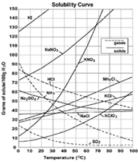

**Solubility Curves**

-Solubility of solids tends to increase with temperature.

-Solubility of gases decrease with increased temperature. e.g. Cooler seas hold more CO₂.

-Solubility of a gas is directly proportional to the pressure of gas above it. e.g. cans of soft drink.

**Solubility of ionic compounds**

-Ionic substances will dissolve if the energy required to separate the ions from the lattice is less than the energy released when the ions are hydrated

-The solubility data on your data sheet can be used to predict the solubility of a substance and to predict whether precipitation reactions will occur (if any combination of ions in a solution are insoluble)

**How to use the solubility data**

-The solubility data lists ionic substances and whether they are soluble or insoluble

-Substances are listed by their negative ion (anion), as this has the main effect on solubility

-Substances containing a particular anion are listed as generally soluble or insoluble and exceptions to the rule are listed

e.g. AgCl: Chlorides are listed as soluble, but AgCl is listed as an exception, so AgCl is insoluble and will therefore be a solid.

NaNO3: Nitrates are listed as soluble and NaNO3 is not listed as an exception, so NaNO3 is soluble and will be aqueous if it is with water.

CuCO3: Carbonates are listed as insoluble and CuCO3 is not listed as an exception, so CuCO3 is insoluble and will be a solid.

**Precipitation & ionic equations**

-A precipitate is defined as a solid that emerges from solution

-Precipitation reactions occur when two solutions are combined, if any combination of the ions in solution can form an insoluble substance

-We can predict the products of a precipitation reaction using our data sheets

-This involves checking the solubility of all ionic compounds that could potentially form

**Predicting the products of precipitation reactions**

e.g. sodium carbonate solution is added to copper (II) chloride solution

- The 4 potential compounds that can form from combinations of ions in the solution are

sodium carbonate, copper (II) chloride, sodium chloride and copper (II) carbonate

-You don't need to check the solubility for sodium carbonate and copper (II) chloride (they must be soluble as they were already in solution)

-sodium chloride is soluble (chlorides are listed as soluble and sodium chloride is not listed as an exception)

-copper (II) carbonate is insoluble (carbonates are listed as insoluble and copper (II) carbonate is not listed as an exception)

-Therefore, a precipitate of copper (II) carbonate will form when the solutions are combined

**Equations for precipitation reactions**

-These reactions can be represented by either a balanced overall equation or with an ionic equation

-For balanced chemical equations, we treat it as if the two ionic compounds have swapped anions, using the general equation

AB + CD → AD + BC

-All solutions will be (aq) and the precipitate will be (s)

e.g. Na2CO3(aq) + CuCl2(aq) → 2NaCl(aq) + CuCO3(s)

**Ionic equations for precipitation reactions**

-It is common to use ionic equations for precipitation reactions (and other reactions that occur in solution)

-Ionic equations represent dissolved ionic substances as their individual ions (as they dissociate when they dissolve) and omit any species that were not directly involved in the reaction (are aqueous on both sides of the equation)

*Steps outlined in “Mr SGs Guide to writing ionic equations*

e.g. Cu2+(aq) +CO32-(aq) → CuCO3(s)

**Making observations for precipitation reactions**

-In addition to predicting the products of a reaction, we can predict the colours of any solutions or precipitates using our data sheets

-Ensure you use the molecular equation when predicting observations, as spectator ions can still alter the colour of solutions

*Steps outlined in Mr SGs guide to predicting observations*

e.g. A blue solution is added to a colourless solution, producing a green precipitate in a colourless solution

**Colligative properties of solutions**

-Colligative properties are the properties of a solution that vary with the concentration of dissolved solutes

-The three colligative properties that we study are vapour pressure, melting point and boiling point

-The presence of a dissolved solute results in lower vapour pressure, lower melting point, higher boiling point

-The extent of the change depends on the number of dissolved particles, but not the type of particles

-Vapour pressure lowering is due to the presence of solute particle preventing some solvent particles with enough energy to evaporate from reaching the surface of the liquid



-Boiling point is raised as the temperature at which vapour pressure = atmospheric pressure is raised

-Melting Point is lowered as presence of solute particles interferes with crystallisation

**Calculations involving solutions**

**Concentration**

-Concentration refers to the amount of solute per unit of solvent

-It can be measured in a number of ways, including:

-Grams per litre (gL-1): concentration (gL-1) = mass of solute (g)

volume of solvent (L)

-% composition (by mass): concentration (% (w/w)) = mass of solute (g) x 100

mass of solution (g)

-Parts per million (ppm): concentration (ppm) = mass of solute (mg)

mass of solution (kg)

-Moles per litre (molL-1) concentration (molL-1) = number of moles of solute (mol)

volume of solution (L)

Also written as c = n

V

-moles per litre is by far the most useful (and hence the most commonly used) measure of concentration used in Chemistry

**Calculating number of moles from the volume and concentration of a solution**

-We can calculate the number of moles of solute present in a given volume of solution, when the concentration is given in moles per litre

n = cV

**Example:** Calculate the number of moles of sodium hydroxide present in 194 mL of a

1.50 molL-1 solution

**Concentration of ions**

-When strong electrolytes dissolve, they will completely ionise or dissociate, allowing us to calculate the concentrations of the ions present in the solution

**Example:** Calculate the number of moles of nitrate ions in 145 L of 0.5 molL-1 magnesium nitrate

**Dilutions**

**-**In chemistry, we will often prepare solutions by making dilutions of stronger solutions

-A dilution is when we add more solvent to reduce the concentration of a solution

-As no extra solute is added, the number of moles (n) is constant.

-As n = cV, if n is constant cV must also be constant; c1V1 = c2V2

-we can use this formula to calculate changes in concentration that occur when we dilute a solution

**Example 3:** Calculate the concentration of a solution prepared by adding 1.2 L water to 300 ml of a 1.5 molL-1 solution of HCl

**Stoichiometry with solutions**

-As we can calculate the number of moles of solute present in a solution, it is possible to solve stoichiometry problems involving solutions

m1 m2

(solids) (solids)

n= m m = nM

M V = n V2

c (solutions)

c1 & V1 n = cV

(solutions) n1  n2 c = n

n = VSTP  V c2

22.71 n2 = coefficient2 x n1 (solutions)

coefficient1 VSTP = n x 22.71

V1(STP)

(gases) n = PV V2(STP)

RT (gases)

V = nRT

V1 P

(gases) V2

(gases)

**Example 4:** Calculate the volume of carbon dioxide produced (at 100 kPa and 25C) when utionsons involving ble and excess solid sodium carbonate is added to 348 mL of 2.00 molL-1 sulfuric acid.